Password-based authentication
# Source: AI Source: Provided by: [Data Path: Persons Table -> ID Column: 1, Name_En Column: Motasem Essam] -> From: [Chatgpt (GPT‑5 Mini)] on [1/20/2026]
Password-based authentication is the most common and traditional way to verify a user’s identity — where the user provides a username (or email) and a secret password.

🧠 In Simple Terms:
# Source: AI Source: Provided by: [Data Path: Persons Table -> ID Column: 1, Name_En Column: Motasem Essam] -> From: [Chatgpt (GPT‑5 Mini)] on [1/20/2026]
You prove who you are by entering something only you should know: your password.

✅ How It Works
# Source: AI Source: Provided by: [Data Path: Persons Table -> ID Column: 1, Name_En Column: Motasem Essam] -> From: [Chatgpt (GPT‑5 Mini)] on [1/20/2026]
- You enter your username and password.
- The server checks the password against the one stored (usually hashed).
- If they match, you're authenticated.

🔄 Example Flow:
# Source: AI Source: Provided by: [Data Path: Persons Table -> ID Column: 1, Name_En Column: Motasem Essam] -> From: [Chatgpt (GPT‑5 Mini)] on [1/20/2026]
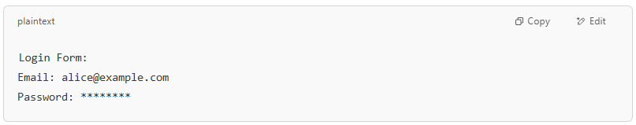
Login Form:
Email: alice@example.com
Password: ********

🔐 Security Best Practices
# Source: AI Source: Provided by: [Data Path: Persons Table -> ID Column: 1, Name_En Column: Motasem Essam] -> From: [Chatgpt (GPT‑5 Mini)] on [1/20/2026]

Practice | Why It Matters
Hash passwords (e.g., bcrypt) | Never store raw passwords — hashing makes them unreadable
Use HTTPS | Prevents password leaks during transmission
Limit login attempts | Prevents brute-force attacks
Add 2FA | Adds another layer of security
Require strong passwords | Harder to guess or crack

❌ Weaknesses
# Source: AI Source: Provided by: [Data Path: Persons Table -> ID Column: 1, Name_En Column: Motasem Essam] -> From: [Chatgpt (GPT‑5 Mini)] on [1/20/2026]
- Users often choose bad passwords (e.g., "123456")
- Passwords can be stolen (phishing, leaks, malware)
- Reused passwords make other accounts vulnerable if one gets hacked

🔁 Example from Real Apps
# Source: AI Source: Provided by: [Data Path: Persons Table -> ID Column: 1, Name_En Column: Motasem Essam] -> From: [Chatgpt (GPT‑5 Mini)] on [1/20/2026]

App | Password-Based Login
Gmail | Email + password
Facebook | Phone/email + password
Bank Apps | Username + password

Summary
# Source: AI Source: Provided by: [Data Path: Persons Table -> ID Column: 1, Name_En Column: Motasem Essam] -> From: [Chatgpt (GPT‑5 Mini)] on [1/20/2026]
Password-based authentication = The user logs in using a secret password.
It's simple, but needs strong security practices to be safe.

